A New Rationale and Treatment Model for Neuromuscular Tender Points

Brian Tuckey PT, Jay P. Shah MD, Hannah Tandon BA
© 2017 Tuckey Continuing Education Services LLC

Abstract
This paper presents a novel expansion of the osteopathic technique of Strain and Counterstrain (SCS), originally developed by Lawrence Jones, DO. While SCS focuses on examining and treating the musculoskeletal system, Fascial Counterstrain (CS), presented here, provides a treatment and pathophysiological model that integrates all systems of the body into Jones’s concept of neuromuscular dysfunction. In CS, TPs (including traditional SCS TPs) are identified and treated with specialized fascial glides targeted to local nociceptors and mechanoreceptors instead of traditional Jones positions of comfort. Additionally, this model outlines a process to identify treatments for previously undescribed neuromuscular TPs, two of which are described in the paper. These newly-developed treatments have been empirically validated through years of successful patient outcomes in a variety of patient populations.
A physiological rationale for the CS treatment model is presented that incorporates concepts of central processing and the science of fascia. Neurons located in the deep fascia have both nociceptive and mechanoreceptive properties and respond to low threshold pressure changes. Repeated peripheral nociceptive input from the fascia into the central nervous system can cause a prolonged or ongoing increase in nociceptive pathway excitation, resulting in central sensitization. This, combined with subsequent excitation of peripheral nociceptors, can effectively create system-specific TPs. CS treatments decompresses local nociceptors and mechanoreceptors, mechanically deactivating them. This reduces peripheral nociceptive input to the spinal cord, reverting central processing back to its normal, non-excited state.
The CS case study presented is that of calcific shoulder tendonitis which failed to respond adequately to arthroscopic sub-acromial decompression and a 6-week standard course of post-operative rehabilitation. The patient was subsequently referred for a trial of CS in an attempt to avoid calcific nodule resection and complete rotator cuff repair. Following CS treatment, the patient regained full strength, full range of motion, and reported significant pain relief. Additionally, x-ray evidence demonstrated 100% reabsorption of the calcific nodule in a time frame that is 92% faster than average reabsorption time with standard treatment. These promising case results and the associated physiological rationale suggest that CS provides an effective and targeted multi-system treatment which merits further study.

INTRODUCTION
Fascial Counterstrain is a modern, expanded version of the osteopathic technique Strain and Counterstrain in which all systems of the human body are assessed and treated, not just the musculoskeletal system. A new explanation of fascial/neuromuscular tender points is presented that utilizes the modern concepts of central processing and the emerging science of fascia as a contractile sensory organ. We suggest that the body protects all tissues, not just musculoskeletal structures, via nocifensive reflexes orchestrated by the fascial system. A Fascial Counterstrain case study is presented to demonstrate the concept of multi-system fascial manipulation and its potential impact on a myriad of musculoskeletal and non-musculoskeletal medical conditions.
BACKGROUND
Strain and Counterstrain (SCS), also known as Positional Release, is a passive positional technique developed by Lawrence Jones, DO, aimed at relieving musculoskeletal (MS) and fascial pain through the use of indirect (non-painful, reflex-based) manual manipulation (D'Ambrogio & Roth 1997). SCS is a common form of soft tissue manipulation practiced by osteopathic physicians, physical therapists, and other manual medicine practitioners worldwide (Johnson & Kurtz 2003; Saphy et al. 2016).
SCS has multiple clinical indications and has been utilized to treat disorders involving pain, edema, joint hypo-mobility, skeletal muscle tension, muscle weakness, and fascial tension (Chaitow 2007; D'Ambrogio & Roth 1997; Wong 2012). Initially, tender points (TPs) are identified to diagnose neuromuscular dysfunction and are monitored over the course of treatment to assess clinical progress. Physically, TPs were described by Jones as ‘tense, tender, edematous masses about 1 cm in diameter’ and have been documented in both muscular and fascial locations (Chaitow 2007; D'Ambrogio & Roth 1997; Jones 1995). After a diagnostic TP is identified, patients are passively placed into specified positions for up to 90 seconds to release the TP (Chaitow 2007; D'Ambrogio & Roth 1997; Jones 1995; Wong 2012). In the classic SCS model, no distinction is made between TPs and myofascial trigger points (Trps), but a discussion of how they are related will be given later in the framework of the proposed CS model.
The proposed physiological mechanisms behind SCS are theoretical. Historically, the proprioceptive or Korr hypothesis of joint dysfunction has been utilized to explain the effects of SCS (Wong 2012). In this theory, aberrant neuromuscular reflexes caused by dysfunctional muscle spindles lead to joint fixation and dysfunction (Korr 1975). Through passive positioning, SCS is believed to reset the dysfunctional proprioceptors to baseline sensitivity, normalizing the stretch reflex and restoring pain-free function to the involved joint.
In 1990, Van Buskirk questioned the validity of the proprioceptive model (Van Buskirk 1990). He argued that muscle spindle activity alone is neither necessary nor typically sufficient to produce isolated skeletal muscle contraction and that other tissue proprioceptors exist, such as nociceptors that can cause a similar clinical presentation. He argued for a nociceptive model that could account for the fact that joint dysfunction is known to be caused by non-muscular tissues like the viscera, which do not contain muscle spindles. In 2005, the Van Buskirk nociceptive model was updated to include new research related to the excitation of segmental dorsal root reflexes and the potential for pain modulation from descending Central Nervous System (CNS) pathways (Howell & Willard 2005).
The scope of SCS treatment has been expanded over the last 20 years by the lead author, Brian Tuckey PT, OCS, (BT) a disciple of Jones. One of only four physical therapists to be certified to teach SCS by Jones, BT has identified over 500 previously undocumented neuromuscular TPs, a significant number of which require manipulation of non-muscular structures in order to alleviate the clinical signs and symptoms. While these newly identified TPs are located in surface muscle or fascial tissues, manipulative forces are typically applied to underlying anatomical tissues including the visceral fascia (peritoneum), vascular fascia (tunica adventitia), ligaments and all aspects of the nervous system (epineurium). This new, multi-system form of SCS is called Fascial Counterstrain or simply Counterstrain (CS) (Saphy et al. 2016; Tuckey 2008, 2011, 2013, 2014, 2015a, b, c). CS TPs are believed to impact the function of the specific systems to which they relate through reflexive connections to the CNS. A theoretical physiological rationale is offered to explain the effects of this new form of SCS, one that takes into consideration the modern concepts of central sensitization and the expanding role of fascia as a sensory organ.
MATERIALS AND METHODS
CS treatment differs from classic SCS treatments described by Jones in that fascial glides, not treatment positions, are utilized to facilitate a release (Jones 1995; Tuckey 2015c). The following sequence details the steps involved in a CS TP release. The specific physiological changes described in each step will be discussed later in the manuscript.
- A diagnostic TP is identified.
- A fascial glide or joint movement is performed that unloads the involved structure. This manipulation is performed to the specific tissue that has been clinically identified to release the TP. The structure manipulated may be MS, visceral, neural, or vascular in origin.
- This tissue-specific manipulation decompresses local nociceptors and mechanoreceptors, mechanically deactivating them.
- The treatment or decompressed position is maintained for 15-45 seconds. This allows any noxious substances in the surrounding area to dissipate, alleviating chemical irritation of the involved peripheral nociceptors.
- The technique is repeated to other TPs located in the targeted region/limb/etc. This reduces peripheral fascial nociceptive input to the spinal cord, reverting central processing back to its normal, non-excited state.
- Fascial tonus is reduced and nocifensive reflexes are returned to normal, resolving tissue texture abnormalities and restoring pain-free mobility to the involved structures.
- Sympathetic activation is reduced as central processing normalizes, reducing ischemia and edema in the vascular bed.
- The patient is re-assessed to verify resolution of the involved TPs and to assess improvements in pain, mobility, edema, function, etc.
Extensive manipulative experience and anatomical knowledge is required to identify TPs not previously described in SCS. In addition to training under Jones, the author (BT) studied multiple forms of manipulation over a 26-year period to gain proficiency in joint mobility testing and the ability to differentiate, using palpation, between different soft tissue types (e.g. muscular vs. visceral tissues.) The following sequence details the general empirical method utilized by BT to identify and name new CS TPs.
- The patient is assessed and given CS treatment to all SCS TPs present.
- If symptoms persist, joint motion testing and tissue texture abnormalities are used to identify additional TPs not previously described in SCS.
- If a TP is identified, regional tissues including local skeletal muscle, ligaments, neuro-vascular structures, and the underlying viscera are manipulated in a 3-dimensional manner until a general vector (depth, direction and tissue location) is identified that alleviates the TP. This manipulation or glide is held for 15-45 seconds depending on the severity of the TP.
- Following a successful release, the patient is assessed to identify improvements or changes in mobility, pain, digestion, sensation, strength, balance, and/or other objective/subjective findings.
- Additional TP examinations and treatment sessions are performed until the patient reaches maximum benefit or the symptoms have fully resolved. The reduction in peripheral nociception following CS treatment may allow the associated maladaptive CNS plasticity to normalize, even in supraspinal structures like the thalamus or limbic system.
To validate a newly identified TP, additional patients are examined and treated until the exact vector is verified that consistently results in a lasting release. The new TP is named based on the anatomical structure that may match the TP’s 3-dimensional vector. Whenever possible, the suspected anatomical structure (not just the surface diagnostic TP) is palpated for tissue texture changes before and after treatment to verify the association. Treatment response and symptoms are analyzed over time to confirm the suspected anatomical structure. For example, a newly identified TP is confirmed to be related to the ulnar nerve when treatment resolves pain and paresthesias experienced in the 4th and 5th digits.
THEORETICAL RATIONALE FOR ‘FASCIAL’ COUNTERSTRAIN
CS integrates fascia into the SCS model. There are two types of fascia: superficial and deep. Superficial fascia lies beneath the skin and plays a role in thermoregulation and skin turgor and is highly innervated. Deep fascia, on the other hand, lines muscle groups and organs and has long been called the ‘organ of form’ because of its role in offering structure and form to the human body (Garfin et al. 1981).
Recent research has demonstrated that deep fascia serves more than a structural purpose. All types of deep fascia, including tunica adventitia, peritoneum, epineurium, and myofascia (muscular fascia), have been shown to have extensive proprioceptive properties due to Type III and IV neurons (Feindel et al. 1948; Mitchell & Schmidt 2011; Ruch 1979; Schleip 2003; Stacey 1969; Stilwell 1957a, b). These neurons, rarely mentioned in physiological textbooks, are the predominant types of free nerve endings in deep fascia. The receptors have both nociceptive (pain sensing) and mechanoreceptive (movement sensing) properties and respond to even low threshold pressure changes such as light touch (Mitchell & Schmidt 2011). The pain experienced through excitation of fascial nociceptors is variable and can range from dull to sharp and from localized to diffuse (Geldard 1974; Landau & Bishop 1953). Because the deep fascia is effectively the outer layer of all tissues, it has been called the “largest sensory organ” in the human body (Schleip 2003). In general, nociceptors can be stimulated by mechanical, chemical, or thermal mechanisms including postural strain, disease states, physical trauma, and/or inflammation (Mitchell & Schmidt 2011; Mountcastle 1980; Schleip 2003). Once stimulated, peripheral nociceptors send signals to the spinal cord, activating secondary neurons that eventually ascend into the pain perceiving regions of the brain (Fryer 2016; Woolf 2011). The dorsal root ganglion neurons subsequently release inflammatory chemicals like substance P, bradykinin, and calcitonin gene-related peptide (CGRP) back into the peripheral tissues via antidromic nerve conduction. This ‘dumping’ effect of inflammatory mediators back into the periphery exacerbates the existing peripheral inflammatory response causing hyperalgesia (abnormally heightened sensitivity to a noxious stimulus) (Willis et al. 1998).
Nociceptor activation may stimulate the autonomic nervous system. The most common effect of this is an elevation in sympathetic tone or sympathetic nervous system activation (SNA). At the spinal cord, interneurons and even some of the peripheral nociceptors' afferents project to the preganglionic neurons of the inter-mediolateral column producing autonomic effects including vasopressor/vasodilator effects, gastrointestinal stasis, and even alterations in immune function (Benarroch 2006; Cortelli & Pierangeli 2003; Foreman et al. 1984; Irvin et al. 1970; Johansson 1962; Mitchell & Schmidt 2011; Purslow 2010; Sato et al. 1979). Other somatic and/ or visceral afferents project to the motor neurons of the ventral horn, driving MS protective reflexes called nocifensive reflexes. Some of these MS reflexes are local while others are multi-segmental contractions that the body utilizes to minimize noxious sensations which can manifest clinically as pain, limited mobility, even postural asymmetry (Howell & Willard 2005; Megirian 1962). In addition, visceral and somatic afferent nerves are known to converge into the same neurons at both the spinal cord (dorsal horn) and mid brain (ventrolateral periaqueductal gray) level. These shared visceral and MS nocifensive responses are known as viscero-somatic or somato-visceral reflexes and must be considered when evaluating patients with organ and/or somatic complaints (Cameron et al. 2008; Foreman et al. 1984).
SNA has been shown to cause ongoing arterial vasoconstriction and is known to be spinal-segment specific and therefore organ specific (Hijmering et al. 2002; Malpas 2010). The subsequent disruption of circulation has been associated with renal failure, hypertension, and heart disease (Malpas 2010). Ongoing sympathetic activation may also cause a decrease in circulation to muscle tissue, the long term effects of which would logically lead to trophic changes such as muscle fiber and or tendon degeneration (Janig & Habler 1995).
Furthermore, second order noci-responsive neurons in the spinal cord can be stimulated which ascend via the spinothalamic and spinocervicothalamic tracts to the brainstem and thalamus (Ab Aziz & Ahmad 2006). The impact on the CNS can manifest as secondary hyperalgesia (pain located outside the primary area of injury) and even allodynia (pain to a non-noxious stimulus) (Ruch 1979; Woolf 2011). This concept of central sensitization, where repeated peripheral nociceptive input into the CNS causes a prolonged or ongoing increase in nociceptive pathway excitation, is a well-established phenomenon which can set up a positive feedback loop between central and peripheral nociceptors. This loop fosters the development of chronic pain conditions including fibromyalgia, temporomandibular dysfunction, and visceral pain syndromes (Fryer 2016; Woolf 2011).
Additional supraspinal influences such as increased limbic system activity can also occur in cases of myofascial pain syndrome (MPS). Niddam et al. demonstrated increased limbic system (i.e., anterior insula) activity in patients with upper trapezius MPS which can affect pain modulation and potentially cause psychological symptoms such as fear and anxiety (Niddam et al. 2007).
Central sensitization and subsequent excitation of peripheral nociceptors manifests clinically as pressure hyperalgesia, which lowers tissue pressure pain thresholds, effectively creating TPs (Woolf 2011). Many forms of osteopathic diagnosis have been shown to have poor reliability; however, research has demonstrated acceptable inter-examiner reliability using tissue palpation as a diagnostic criterion thus supporting the use of TP examination over other forms of manual diagnoses such as segmental motion testing (Seffinger et al. 2004).
In the CS approach, TPs are the primary finding by which a diagnosis is made. The concept of CS TPs (by definition tense, tender, edematous masses) accurately describes the presence of tissue edema as well as localized pressure hyperalgesia. Thus, the clinical signs and symptoms of the CS TP can be reasonably accounted for by utilizing the modern concepts of centrally stimulated nociceptors. Since nociceptors from all tissue types can excite interneurons at the spinal cord level, different systems could be injured or inflamed and act as the primary pain source or primary hyperalgesia location. Secondary hyperalgesia can therefore exist in surface MS locations despite originating from a completely different innervated tissue source such as a vascular or visceral structure (Fryer 2016; Meyer et al. 2005). Once created, TPs can be maintained by central mechanisms including spinal plasticity (maladaptive re-organization of spinal cord neurons) or by continued peripheral nociceptive input as patients continue to function in the presence of activated or symptomatic TPs (Woolf & Salter 2000).
In addition to the presence of nociceptors and mechanoreceptors, research has demonstrated that fascia has intrinsic contractile properties due the presence of myofibroblasts (Purslow 2010; Schleip 2003). Schleip et al. (2005) measured the force of perimysial intermuscular fascia and found it to be sufficient to impact musculoskeletal behavior and/or gamma motor neuron activity around an involved joint. The ability of deep fascia to contract may help explain the last characteristic of CS tender points: ‘tissue texture change’ or the fact that tender points are palpable, even in anatomically neutral positions. In the past, paraspinal tissue texture changes in the region of pain have been attributed to reflex skeletal muscle contraction, however, more recent studies have not demonstrated resting EMG activity at the location of tissue change, calling into question the idea of ongoing, localized alpha motor neuron excitation (Fryer 2016). A plausible explanation for a localized increase in palpable muscle and/or fascial tone at rest, would be that practitioners are able to perceive not only localized edema but also contracted fascia related to the peripheral or central excitation of fascial nociceptors. Considering that perimysial fascia contributes to the pressure inside a muscle through its structural, physiological, and metabolic properties, it is conceivable that perimysial fascial contraction could cause a clinically recognizable increase in muscle tonus (Garfin et al. 1981).
The Effect of Reducing of peripheral Nociceptive Input on Central Sensitization
In 1992, Cohen et al. coined the term ‘refractory cervicobrachial pain’ (RCBP) after observing an ‘epidemic’ of cases involving patients with the clinical features of neuropathic pain (pain initiated or caused by a primary lesion or dysfunction in the nervous system) but in whom no radiculopathy, peripheral neuropathy, arthropathy, or myopathy could be identified. These patients presented with allodynia, pain on joint movement, cutaneous hypoaesthesia, and impaired motor function. Several patients who presented with autonomic symptoms, also received sympathetic (stellate ganglion) blocks without consistent resolution of pain symptoms, ruling out sympathetically mediated pain as the primary cause. Multiple sites of analgesic and/or sympathetic blocks, however, were found to significantly reduce the overall pain presentation. Thus, it was concluded that RCBP is due to repeated peripheral afferent nociceptive input from a number of possible tissue sources including capsular, muscular, and/or neural structures resulting in dorsal horn excitation (Cohen et al. 1992). This concept of reversing central sensitization by reducing the afferent barrage of peripheral nociceptive input has been experimentally and theoretically supported by other authors. Gracey et al. (1992) performed local anesthetic blocks of ‘painful foci’ associated with previous trauma (essentially blocking TPs) which abolished mechano-allodynia, cold allodynia, and spontaneous pain in all patients and relieved the motor symptoms in one patient with tonic contractures of the toes. The symptoms gradually returned as the anesthetic waned, demonstrating that peripheral nociception can drive central sensitization and is apparently reversible. In summary, Gracey concluded:
‘We propose a model of neuropathic pain in which ongoing nociceptive afferent input from a peripheral focus dynamically maintains altered central processing that accounts for allodynia, spontaneous pain, and other sensory and motor abnormalities. Blocking the peripheral input causes the central processing to revert to normal, abolishing the symptoms for the duration of the block. The model accounts for sympathetically maintained (SMP) and sympathetically independent (SIP) pain.’ (Gracely et al. 1992)
Although the exact mechanism by which altered central processing is maintained is still debated, Gracey’s findings suggest that treatment of peripheral nociceptive sources can reverse the process. His research also supports the concept that central sensitization cannot exist without ongoing nociceptive input. This supports the CS multi-system model that utilizes the treatment of TPs to reduce the number of nociceptive sources in the periphery and thus reduce the amount of disability and pain experienced by patients during activities of daily living.
In the literature there is a distinction made between fascial TPs and myofascial trigger points (Trps). TPs are described as non-specific soft tissue locations of hyperalgesia that do not respond to local treatments and are often associated with widespread pain syndromes like fibromyalgia (Schneider 1995). On the other hand, Trps are hard, palpable, tender nodules located in a taut band of skeletal muscle that have historically responded well to local treatments. Trps can be classified as either active or latent. An active Trp is associated with spontaneous pain, and strong digital pressure on the active Trp exacerbates the patient's familiar pain experience. Latent Trps, on the other hand, are not associated with a spontaneous pain complaint; however, pressure elicits pain locally at the site of the nodule. Both kinds of Trps can be associated with muscle dysfunction and weakness and limited range of motion. Active Trps have elevated levels of substances known to be associated with pain, inflammation, sensitization, and intercellular signaling as compared to healthy skeletal muscle tissue (Shah & Gilliams 2008). These biochemicals include inflammatory mediators, neuropeptides, catecholamines, and cytokines. This supports the concept of active Trps being areas of primary hyperalgesia capable of initiating the process of central sensitization.
It is important to note that in CS, there is no distinction made between TP and Trps. All Trps and TPs can be treated successfully with CS manipulation. While in the literature Trps are often described solely in terms of myofascia, CS considers a potential protective relationship of Trps with underlying visceral, vascular, and neural tissues related to nocifensive reflex arcs. Whether they are purely MS or relate to another system through these reflex arcs, Trps are monitored and released in the same fashion as a TP found on a bony landmark. This means in CS, Trps are essentially considered a subset of TPs. Therefore identification and naming of a Trp in CS follows the same protocol as that for any TP.
Because CS practitioners do not distinguish Trps from the larger category of TPs for purposes of assessment and treatment, for the remainder of this discussion, ‘TPs’ will be used to describe all focal areas of tissue texture abnormality including those that could also be defined as Trps. For example, Figure 1 illustrates a TP (which in this case, fits the definition of a Trp) located in the proximal portion of the reflected head of the rectus femoris muscle. This TP empirically has been found to not respond to manipulation of the quadriceps however does release in response to a fascial glide applied to the ipsilateral ileum and associated peritoneal fascia. Thus the TP has been named ‘ileum’ instead of ‘rectus femoris’ (indicating visceral, not MS origin).
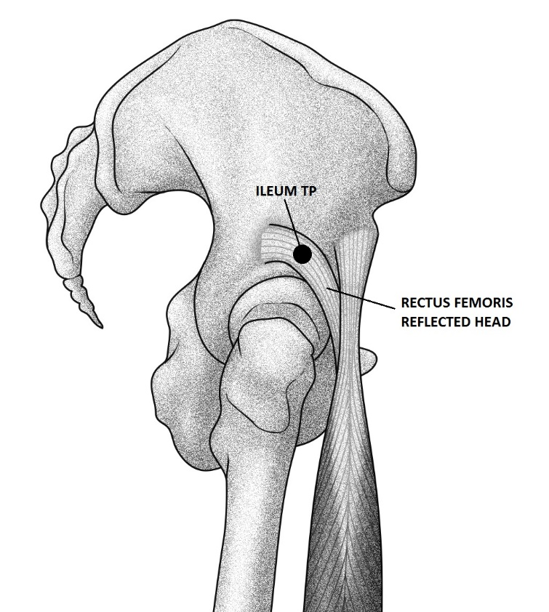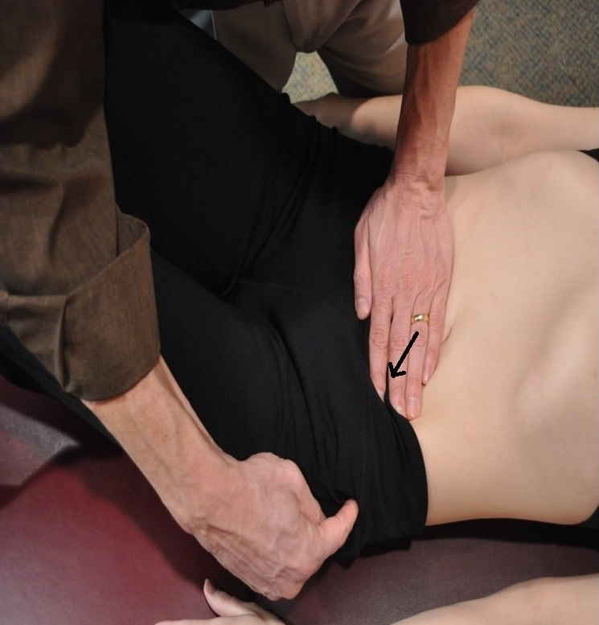
(a)
(b)
(b)
Figure 1
RATIONALE FOR MULTI-SYSTEM TP FORMATION
The following sequence details the proposed mechanism of TP formation after recognizing fascia as a dynamic, multi-system sensory organ and incorporating the concepts of central sensitization. This model is essentially an expanded version of the ‘nociceptive’ model proposed by Van Buskirk in 1990:
- Trauma, inflammation, postural strain, or disease stimulates Type III and Type IV fascial nociceptors and/or mechanoreceptors. The primary nociceptive tissue can be musculoskeletal, visceral, vascular, or neural.
- Stimulated peripheral nociceptors activate neurons in the dorsal root ganglia and dorsal horn of the spinal cord, causing excitation.
- These centrally stimulated nociceptors anti-dromically release, via neurogenic inflammation, chemicals like Substance P and CGRP back into the peripheral tissues causing inflammation, leading to TP formation.
- In some instances, peripheral nociceptors can excite neurons in the spinal intermediolateral system causing SNA. This chronic increased sympathetic activity will create arterial and/or venous vasoconstriction potentially leading to organ damage, impaired immune responses, and/or MS trophic changes.
- Fascial contractility will be stimulated in the local area leading to exaggerated nocifensive and gamma motor neuron reflexes, regardless of the underlying tissue source. The patient will present with pain, limited mobility, tissue texture changes, and impaired function.
- The patient will subsequently experience increased nociceptive input as they must function in the presence of exaggerated nocifensive reflexes and peripheral inflammation.
- Second order spinal neurons will be repeatedly stimulated carrying nociceptive impulses to the brainstem, limbic system, and thalamus. This can lead to an exaggeration of normal pain perception in the CNS, which adds to the existing hyperalgesia and peripheral nociceptive input.
- Plasticity or maladaptive changes can occur in the CNS leading to allodynia, further impairing function.
- A chronic state of hyperalgesia is created, with or without sympathetic effects, in which all movement that goes against the established nocifensive reflexes is limited and painful. If SNA exists, arterial, venous, and/or lymphatic vasoconstriction will occur, limiting the ability of these systems to remove inflammatory mediators from the periphery and/or leading to trophic changes. This accounts for a large number of clinical conditions and syndromes where patients present with MS, neural, visceral, and/or vascular symptoms.
This multi-system fascial model would provide MS protection via nocifensive reflexes to all tissues, not just MS tissues. It seems improbable that the body would exclusively protect the MS system (via the gamma motor system) and not create a protective mechanism, such as the one described, to protect the more vital visceral, neural and vascular structures.
FASCIAL COUNTERSTRAIN CASE STUDY
History: Alisha, a 37-year-old white female, presented for an orthopedic consultation due to a six-year history of left shoulder pain and disability. The pain was described as a maximum of 10/10 with activities of daily living and reportedly did not respond to cortisone injection.
Diagnostic testing: The original MRI, performed three months prior to this visit, demonstrated a large calcific nodule in the Supraspinatus tendon as well as a ‘possible’ SLAP (superior labral tear) lesion. The calcific nodule was measured at 1 to 1.5 cm long. A subsequent MRI and X-ray performed following the orthopedic consultation verified the existence of a large calcific nodule which made up ‘a fairly large part of the Supraspinatus attachment, especially anteriorly,’ according to the attending orthopedist.
Orthopedic treatment: After reviewing the patient’s diagnostics and history, the orthopedist recommended sub-acromial decompression with debridement of any non-encapsulated calcium deposits.
Surgical intervention: Three weeks later, a sub-acromial decompression with ‘limited calcific debridement’ was performed. The calcific nodule was visualized during surgery and was not removed as it was ‘quite large’ and excision would have required a complete rotator cuff repair. Following shoulder decompression, the patient was referred for standard post-operative physical therapy consisting of modalities, passive stretching, and a program of strengthening exercises.
Results of decompression and standard rehabilitation: Five months after initial consultation and four and a half months following sub-acromial decompression and standard rehabilitation, the patient returned to the orthopedist with continued complaints of shoulder pain and functional loss. She had been discharged from physical therapy after approximately 12 visits having reached maximum benefit. X-rays performed at this visit demonstrated no change in the calcific nodule that had now been present for at least eight months (see Figure 2).
Three-month surgery and rehabilitation follow-up: Eight months after the initial consultation, the orthopedist informed the patient that she would require a second, more invasive surgery to excise the calcific nodule. This second procedure, due to the amount of tissue that would need to be removed during the excision, would require a complete repair of the rotator cuff.
At that time, the patient requested to be referred to BT for CS treatment, in an attempt to avoid a second surgical procedure.
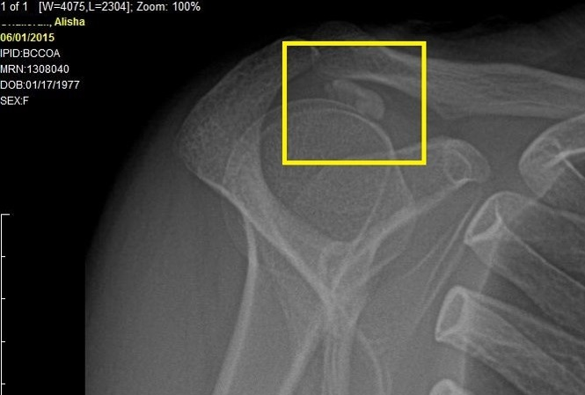
Figure 2
Initial evaluation: One month later, the initial physical therapy evaluation and CS treatment was performed. DASH (disabilities of the arm, shoulder, and hand) index demonstrated a 56% disability score. The pain was described as increasing, rated a constant 5/10 in the shoulder and cervicothoracic spine. The patient reported a progressive deterioration in function and was unable to reach overhead or sleep through the night. Shoulder flexion was pain limited at 140/180 degrees and abduction at 100/180 degrees. CS evaluation procedures identified multiple severe vascular, neural, and MS TPs in the left (involved) shoulder while only a limited number of mild TPs were identified in the uninvolved (right) shoulder. Although several systems of fascial TPs were identified, the TPs related to the sympathetic nervous system and Suprascapular artery were found to be the most sensitive and therefore diagnostic. In the CS model, this indicated impairment of arterial perfusion in the region of the left shoulder and rotator cuff (particularly the Supraspinatus.)
CS treatment: Initial treatment consisted of CS to the post-ganglionic sympathetics from C5 to T3 and the Suprascapular artery (see Figure 3). The second treatment (also exclusively CS) was targeted primarily to axillary fascia and neurovascular bundle to improve shoulder mobility and upper extremity blood flow. Over six months, a total of 18 sessions of CS were performed to the shoulder, TMJ, cervical spine, and thoracic spine in order to alleviate pain and restore functional range of motion all involved regions.
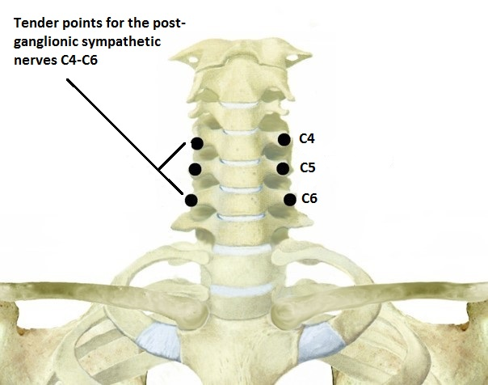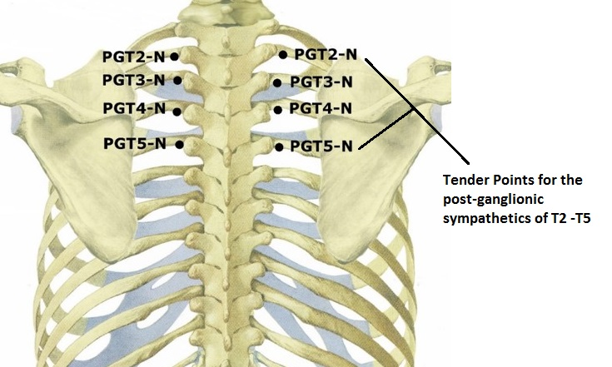
(a)
(b)
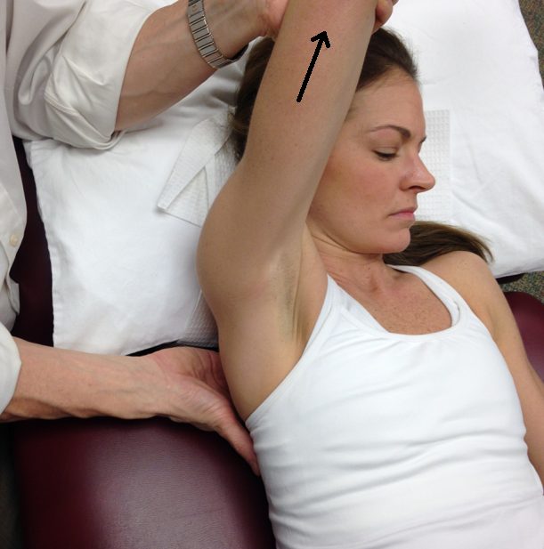
(c)
Figure 3
CS treatment results: After the first treatment visit, the patient reported that she was able to sleep through the night for the ‘first time since the pain started,’ six years earlier. By the 11th visit she reported a 75% improvement in pain and was able to drive and reach overhead without pain. Her shoulder was no longer symptomatic, and treatment focus shifted to her TMJ, cervical spine, and thoracolumbar spine (per patient request).
Eight months after initiation of CS treatment, the patient had returned to full ADLs and was no longer being treated for her shoulder condition. During a routine follow-up visit with her orthopedist, she was found to have normal strength, normal range of motion, a negative impingement test, and near 100% subjective pain reduction. X-rays taken that day demonstrated full and complete resolution of the calcific nodule (see Figures 4 and 5).
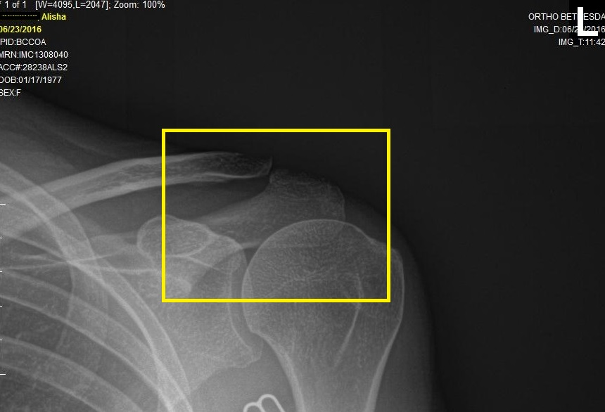
Figure 4
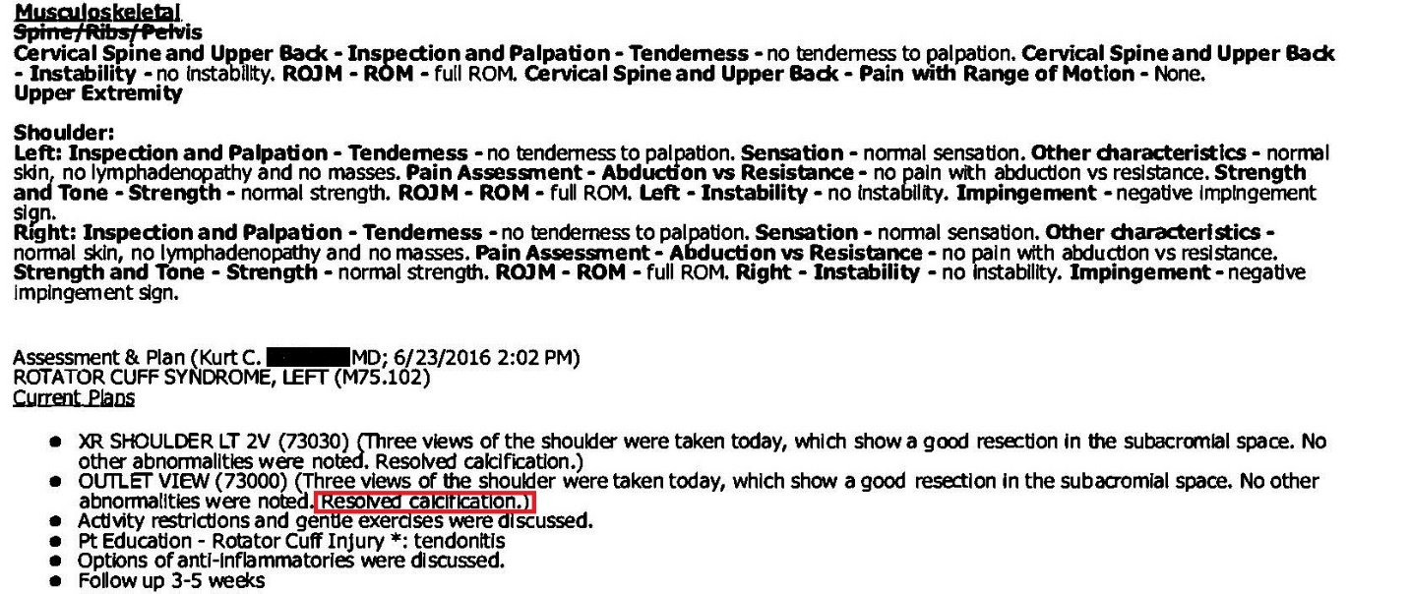
Figure 5
CASE STUDY DISCUSSION
Prior to CS treatment, this patient had more than six years of shoulder pain and functional disability. Her treatment history included four orthopedic consultations, a cortisone injection, a sub-acromial decompression, and six weeks of standard post-operative physical therapy without resolution of her condition. At the time of referral, the calcification was clearly visible on X-ray and would likely have been graded in the moderate to severe range (type I or II) according to Gärtner and Heyer due to the calcification’s size and well defined borders (Gärtner & Heyer 1995).
The etiology of calcific tendonitis is currently unknown (Uhthoff et al. 1976). Research has demonstrated that calcific tendonitis, which occurs commonly in younger individuals, is often a self-limiting condition. Bosworth found the average rate of radiographic spontaneous resolution of calcific deposits to be 6.4% per year or 15 years for full reabsorption (Bosworth 1941). The calcific reabsorption rate can be accelerated with the addition of non-operative treatment according to Wolk and Wittenberg (Wolk & Wittenberg 1997). They reported a sonographic resolution rate of 82% within 8.6 years with conservative treatment. With regards to pain, research demonstrates that calcific tendonitis symptoms (not calcification reabsorption) requires on average 4.4 years to resolve with treatment; however, it can take up to 13.5 years in some cases (Ogon et al. 2009).
In this case study, the patient had significant symptom reduction (able to sleep through the night for the first time in six years) after one treatment with CS targeted to the sympathetic nervous system and vascular fascia. Full resolution of symptoms and complete radiographic calcific reabsorption was achieved within eight months of the onset of treatment, verified by independent orthopedic consultation and diagnostics (Figures 4 and 5). This is a significantly shorter period of time than is typically associated with standard, conservative treatment (4.4 years for symptom relief and 8.6 years for calcific reabsorption). Reabsorption, in this case, occurred 92% faster than average, possibly due to the contribution of CS treatment. Because no radiographs were taken before eight months after initiation of treatment, it is possible that calcific reabsorption began even earlier. Additional research is needed to determine treatment outcomes, but the results from this case study are promising.
We hypothesize that these case study results were due to a reduction in SNA following the application of CS technique. Successful release of multiple fascial TPs reduces nociceptive input to the spinal cord, leading to a normalization of sympathetic firing and reduction of central sensitization. This alleviates vasoconstriction and improves vascular perfusion to the rotator cuff, thus rapidly accelerating the natural reabsorption process.
CONCLUSION
Fascial Counterstrain is a newly developed clinical tool designed to reduce nociceptive input from all fascial systems with the ultimate goal of normalizing nocifensive reflexes and eliminating central sensitization. The proposed physiological rationale can explain the existence of fascial tender points and how they relate to other body systems by utilizing the modern concepts of central processing and the emerging science of fascia as a contractile sensory organ. We suggest that the body protects all tissues, not just musculoskeletal structures, via nocifensive reflexes orchestrated by the fascial system. While further research is needed to fully validate the treatment strategy described, the rationale and case study presented support the use of Fascial Counterstrain in cases of musculoskeletal pain related to sympathetic nervous system activation. Counterstrain has the potential to offer a new primary treatment method for numerous idiopathic medical conditions that are known to exist in virtually every field of medicine.

Acknowledgements
The author BT is heartily thankful to his mentors Lawrence Jones D.O. and Randy Kusunose PT who freely gave their time and knowledge so that he was able to gain expertise in Strain and Counterstrain. He would like to thank the Jones Institute for providing a platform and the logistical support necessary to reach an international audience with Fascial Counterstrain. In addition, BT would like to thank William Hall Phd for his research assistance, advice and encouragement regarding publication of this article. Lastly, a special thanks to Tim Hodges LMT for his support, friendship and relentless dedication to the teaching and development of Fascial Counterstrain.

Citations
Ab Aziz CB, Ahmad AH 2006 The Role of the Thalamus in Modulating Pain. The Malaysian Journal of Medical Sciences : MJMS 13, 11-18.
Benarroch EE 2006 Pain-autonomic interactions. Neurological Sciences 27, s130-s133.
Bosworth BM 1941 Calcium deposits in the shoulder and subacromial bursitis: a survey of 12,122 shoulders. Journal of the American Medical Association 116, 2477-2482.
Cameron DM, Brennan TJ, Gebhart GF 2008 Hindpaw incision in the rat produces long-lasting colon hypersensitivity. The journal of pain : official journal of the American Pain Society 9, 246-253.
Chaitow L 2007 Positional release techniques. Churchill Livingstone/Elsevier, Edinburgh.
Cohen ML, Arroyo JF, Champion GD, Browne CD 1992 In Search of the Pathogenesis of Refractory Cervicobrachial Pain Syndrome. A Deconstruction of the RSI Phenomenon. Medical Journal of Australia 156, 432-436.
Cortelli P, Pierangeli G 2003 Chronic pain-autonomic interactions. Neurological Sciences: Official Journal of the Italian Neurological Society and of the Italian Society of Clinical Neurophysiology 24 Suppl 2, S68-70.
D'Ambrogio KJ, Roth GB 1997 Positional release therapy: assessment & treatment of musculoskeletal dysfunction. Mosby, St. Louis.
Feindel WH, Weddell G, Sinclair DC 1948 Pain sensibility in deep somatic structures. Journal of Neurology, Neurosurgery, & Psychiatry 11, 113-117.
Foreman RD, Blair RW, Neal Weber R 1984 Viscerosomatic convergence onto T2–T4 spinoreticular, spinoreticular-spinothalamic, and spinothalamic tract neurons in the cat. Experimental Neurology 85, 597-619.
Fryer G 2016 Somatic dysfunction: An osteopathic conundrum. International Journal of Osteopathic Medicine 22, 52-63.
Garfin SR, Tipton CM, Mubarak SJ, Woo SL, Hargens AR, Akeson WH 1981 Role of fascia in maintenance of muscle tension and pressure. Journal of Applied Physiology: Respiratory, Environmental and Exercise Physiology 51, 317-320.
Gärtner J, Heyer A 1995 Calcific tendinitis of the shoulder. Der Orthopade 24, 284-302.
Geldard FA 1974 The Human Senses, 2 ed. John Wiley & Sons, Inc., New York.
Gracely RH, Lynch SA, Bennett GJ 1992 Painful neuropathy: altered central processing maintained dynamically by peripheral input. Pain 51, 175-194.
Hijmering ML, Stroes ESG, Olijhoek J, Hutten BA, Blankestijn PJ, Rabelink TJ 2002 Sympathetic activation markedly reduces endothelium-dependent, flow-mediated vasodilation. Journal of the American College of Cardiology 39, 683-688.
Howell JN, Willard F 2005 Nociception: New Understandings and Their Possible Relation to Somatic Dysfunction and Its Treatment. Ohio Research and Clinical Review 15, 1-4.
Irvin MK, Keith AB, Elliot Lee H, George WN 1970 The potential disruptive influence of somatic input, in: Kugelmass IN (Ed.), The Physiological Basis of Osteopathic Medicine. Postgraduate Institute of Ostopathic Medicine and Surgery, New York, pp. 39-51, 54.
Janig W, Habler HJ 1995 Visceral-autonomic integration, in: Gebbart GF (Ed.), Visceral Pain: Progress in Pain Research and Management. IASP Press, Seattle.
Johansson B 1962 Circulatory response to stimulation of somatic afferents. Acta Physiologica Scandanavia 57, 5-91.
Johnson SM, Kurtz ME 2003 Osteopathic manipulative treatment techniques preferred by contemporary osteopathic physicians. The Journal of the American Osteopathic Association 103, 219-224.
Jones LH 1995 Strain-Counterstrain. Jones Strain-CounterStrain, Boise.
Korr IM 1975 Proprioceptors and somatic dysfunction. The Journal of the American Osteopathic Association 74, 638-650.
Landau W, Bishop GH 1953 Pain from Dermal, Periosteal, and Fascial Endings and from Inflamation: Electrophysiological Study Employing Differential Nerve Blocks. A.M.A. Archives of Neurology & Psychiatry 69, 490-504.
Malpas SC 2010 Sympathetic nervous system overactivity and its role in the development of cardiovascular disease. Physiological Reviews 90, 513-557.
Megirian D 1962 Bilateral Facilitatory and Inhibitory Skin Areas of Spinal Motoneurones of Cat. Journal of Neurophysiology 25, 127-137.
Meyer RA, Ringkamp M, Campbell JN, Raja SN 2005 Neural mechanisms of hyperalgesia after tissue injury. Johns Hopkins APL Technical Digest (Applied Physics Laboratory) 26, 56-66.
Mitchell JH, Schmidt RF 2011 Cardiovascular Reflex Control by Afferent Fibers from Skeletal Muscle Receptors, in: Terjung R (Ed.), Comprehensive Physiology. John Wiley & Sons, Inc., Hoboken, NJ, USA.
Mountcastle VB 1980 Medical physiology, 14 ed. C. V. Mosby Co, St. Louis.
Niddam DM, Chan R-C, Lee S-H, Yeh T-C, Hsieh J-C 2007 Central modulation of pain evoked from myofascial trigger point. The Clinical Journal of Pain 23, 440-448.
Ogon P, Suedkamp NP, Jaeger M, Izadpanah K, Koestler W, Maier D 2009 Prognostic factors in nonoperative therapy for chronic symptomatic calcific tendinitis of the shoulder. Arthritis & Rheumatism 60, 2978-2984.
Purslow PP 2010 Muscle fascia and force transmission. J Bodyw Mov Ther 14, 411-417.
Ruch TC 1979 Pathophysicology of Pain, Physiology and biophysics. Saunders, Philadelphia, pp. 272-324.
Saphy P, Étinne M, Thierry G, Wosinski J, Bellon L 2016 "Strain Counterstrain" du nouveau dans l'approach du Dr. Lawrence H Jones. Profession Kiné 50, 33-36.
Sato A, Sato Y, Schmidt RF 1979 The effects of somatic afferent activity on the heart rate, in: Brooks CM, Koizumi K, Sato A (Eds.), Integrative Functions of the Autonomic Nervous System. University of Tokyo Press/Elsevier.
Schleip R 2003 Fascial plasticity – a new neurobiological explanation: Part 1. J Bodyw Mov Ther 7, 11-19.
Schneider MJ 1995 Tender points/fibromyalgia vs. trigger points/myofascial pain syndrome: a need for clarity in terminology and differential diagnosis. Journal of Manipulative and Physiological Therapeutics 18, 398-406.
Seffinger MA, Najm WI, Mishra SI, Adams A, Dickerson VM, Murphy LS, Reinsch S 2004 Reliability of spinal palpation for diagnosis of back and neck pain: a systematic review of the literature. Spine 29, E413-425.
Shah JP, Gilliams EA 2008 Uncovering the biochemical milieu of myofascial trigger points using in vivo microdialysis: an application of muscle pain concepts to myofascial pain syndrome. J Bodyw Mov Ther 12, 371-384.
Stacey MJ 1969 Free nerve endings in skeletal muscle of the cat. Journal of Anatomy 105, 231-254.
Stilwell DL 1957a The innervation of tendons and aponeuroses. American Journal of Anatomy 100, 289-317.
Stilwell DL 1957b Regional variations in the innervation of deep fasciae and aponeuroses. The Anatomical Record 127, 635-653.
Tuckey B 2008 Fascial Counterstrain for the Viscera.
Tuckey B 2011 Fascial Counterstrain for the Lymphatic System.
Tuckey B 2013 Fascial Counterstrain for the Arterial System.
Tuckey B 2014 Jones Institute Originators of the Strain Counterstrain Technique, Counterstrain for the Nervous System: Upper Body and Cranium.
Tuckey B 2015a Fascial Counterstrain for the Musculoskeletal System and Brain.
Tuckey B 2015b Fascial Counterstrain for the nervous System Lower Quadrant.
Tuckey B 2015c Introduction to Fascial Counterstrain.
Uhthoff HK, Sarkar K, Maynard JA 1976 Calcifying tendinitis: a new concept of its pathogenesis. Clinical Orthopaedics and Related Research, 164-168.
Van Buskirk RL 1990 Nociceptive reflexes and the somatic dysfunction: a model. The Journal of the American Osteopathic Association 90, 792-794, 797-809.
Willis WD, Sluka KA, Rees H, Westlund KN 1998 A contribution of dorsal root reflexes to peripheral inflammation, in: Rudomin P, Romo R, Mendell LM (Eds.), Presynaptic inhibition and neural control. Oxford University Press, New York, pp. 407-423.
Wolk T, Wittenberg RH 1997 Calcifying subacromial syndrome - clinical and ultrasound outcome of non-surgical therapy. Z Orthop Ihre Grenzgeb 135, 451-457.
Wong CK 2012 Strain counterstrain: current concepts and clinical evidence. Man Ther 17, 2-8.
Woolf CJ 2011 Central sensitization: implications for the diagnosis and treatment of pain. Pain 152, S2-15.
Woolf CJ, Salter MW 2000 Neuronal plasticity: increasing the gain in pain. Science (New York, N.Y.) 288, 1765-1769.

Figure Captions

Figure 1. CS release for Ileum, visceral dysfunction (Tuckey 2008). TP is located over the reflected head of the Rectus Femoris muscle, just below the upper rim of the acetabulum (superior, medial, and deep to the greater trochanter) (a). Treatment is performed with the patient supine, and fascial glide is applied to the ileum, beneath the umbilicus, in a posterior, lateral, and slightly inferior direction toward the acetabulum (b).
Figure 2. Three-month follow-up X-ray taken after surgery and standard rehabilitation.
Figure 3. CS release for C4-T5 post ganglionic sympathetic nerves (Tuckey 2014, 2015c). TPs are located over the anterior aspect of the cervical transverse processes from C4-C6 (a) and over the inferior aspect of the rib tubercles 2-5 (b) (Note that the TPs are non-muscular). To palpate TP locations approach anterior to posterior for the C4-C5 locations and inferior to superior for the T2-T5 locations. Treatment is performed with patient supine positioning the shoulder into flexion and adduction with the addition of mild arm traction as needed to resolve the TP (c).
Figure 4. Post CS treatment X-ray.
Figure 5. Post CS treatment, physician follow-up notes.

